AI Resilience
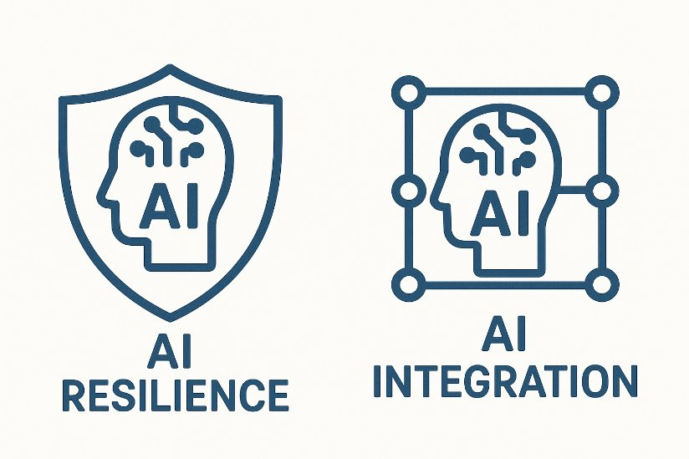
Designed to reduce or eliminate the usefulness of AI for completing the task dishonestly.

Characteristics
- Clear expectations for AI use in syllabus and instructions
- Authentic and context-rich tasks that connect to personal experience
- Visible process (drafts, reflections, steps shown)
- Live performance opportunities (presentations, discussions, in-class work)
- Higher-order thinking emphasized over rote recall
- Multimodal outputs (text, audio, visuals, etc.)

Examples
- In-class writing (Bluebooks)
- Oral exams, live interviews, vlogs
- Unique/personalized prompts
- Process portfolio
- Local case study analysis
- Personal learning narrative

AI Integration
Designed with AI use as a core part of the task, with learning goals adjusted accordingly.

Characteristics
- Clear expectations for AI use in syllabus and instructions
- AI as a partner in the learning process
- Transparent attribution of AI contributions (citing or disclosing use)
- Critical reflection on AI’s role, limits, or biases
- Revised learning goals that account for AI’s presence in the discipline
- Creativity encouraged through novel or exploratory tasks
- Curation skills emphasized (selecting, refining, and integrating AI output)

Examples
- AI-assisted writing drafts
- Comparison assignments (AI vs student work)
- Critique the AI
- Bias/accuracy audit
- AI simulation of opposing view
- Tasks/skills/learning objectives that are NOT being assessed

